Return Filing

**Built and deployment**

This doc is prepared taking following consideration

* The user has the corresponding key file to connect aws server
* File zilla and putty installed

**Contents:**

1. **Modifying client side configuration files :**

Change the returnFiling\public\constants.js with change env value to **prod** , so that client will point to production instances

1. Server side configuration files :

Change the returnFiling\config\default.json with change env value to **prod** , so that server will initialize prod instances

1. Run grunt command as **grunt built**

**AWs connection with file zilla**

File zilla is used to transfer files from our local to the server location

Where in file zilla the left window shows the local path and the right side shows the server path details

Configuring key file:

* Edit (Preferences) > Settings > Connection > SFTP, Click "Add key file”
* Browse to the location of your .pem file and select it.
* A message box will appear asking your permission to convert the file into ppk format. Click Yes, then give the file a name and store it somewhere.
* If the new file is shown in the list of Keyfiles, then continue to the next step. If not, then click "Add keyfile..." and select the converted file.(Here u need to browse the putykey1.ppk file present in the project)
* Go to Site manager -> New site
* Fill in the following information
  + Host: DNS name of EC2 instance.
  + File transfer protocol: SFTP-SSH.
  + Logon Type: Normal.
  + User: Your default username.
  + Password: Leave it as empty.
  + Click Connect button.

**AWs connection with putty**

Putty is used run application command on live server.

1. Open putty

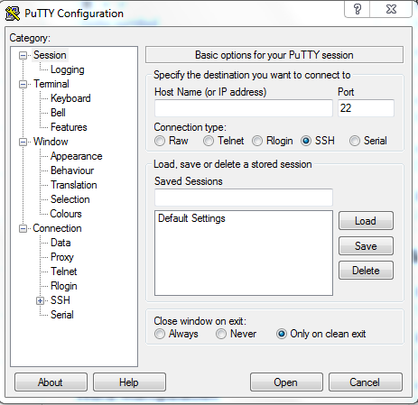

1. In host name write the host name here **ec2-52-23-158-141.compute-1.amazonaws.com**
2. Go to Connection > SSH > Auth
3. Browse the putykey1.ppk
4. Click open

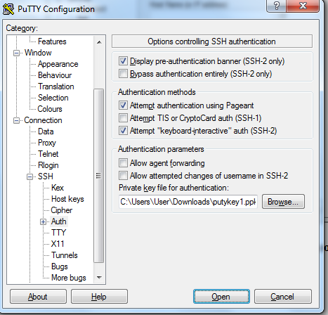

1. Here a console will appear there we need to enter user name as **ec2-user**
2. 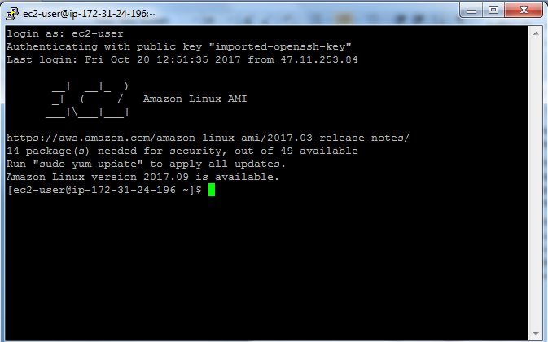

On success this will show above window

1. Enter command **cd /home/ec2-user/ReturnFiling**  in putty console
2. run command

**sudo forever stop bin/www**

1. create a new folder with today date like mmddyyyy format
2. select multiple content as config,server,public,app.js and drag them to mmddyyyy folder to move these folders and files

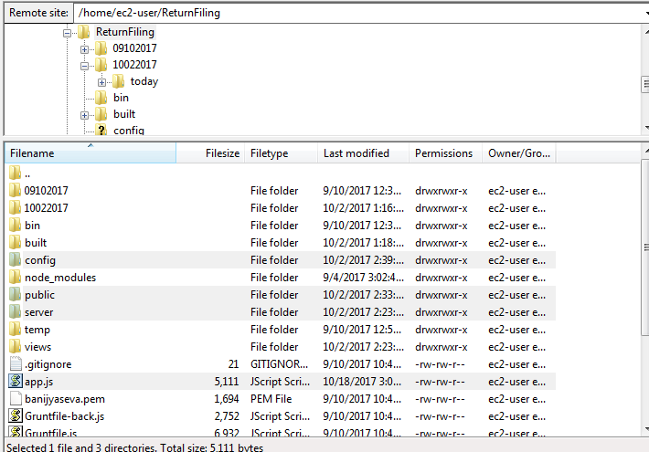

10 move to project folder in by left side window that represents local locations Ex- **C:\xampp\htdocs\returnFiling\built\**

Move **/home/ec2-user/ReturnFiling/public** in server end window

11 drag all content from **C:\xampp\htdocs\returnFiling\built\ >>>> to >>>>>/home/ec2-user/ReturnFiling/public**

**12 .** Move **/home/ec2-user/ReturnFiling (Left side) and /home/ec2-user/ReturnFiling (right side)**

**13 select config , server , app.js from C:\xampp\htdocs\returnFiling and drag to location /home/ec2-user/ReturnFiling**

**14.** In putty console run below commands

**sudo npm start**

By this we can check if any error are coming in console before we make the application live

15 . If all good then terminate the current server execution by CTRL + C

Then run command as **sudo forever start bin/www**